Insurance Policies Clients Analysis

**Introduction:**

As a data analyst, I conducted an in-depth analysis of insurance policies clients, focusing on demographics and car-related factors. The dataset included information from 37,451 clients, revealing intriguing patterns in claiming frequency, amounts, and correlations.

**Project Overview:**

The primary objective was to understand the dynamics of insurance claims among clients based on their demographics and car details.

**Key Findings:**

1. **Claiming Statistics:**

- Total clients: 37,451

- Average claiming frequency: 0.51

- Average claimed amount: $50,000

1. **Client Demographics:**

- Average household income: $147,250

- Predominant residence in highly or moderately urban areas.

*Note: The dataset suggests a financially stable client base with urban living preferences.*

1. **Correlations:**

* Car Age and Claim Frequency:

- Positive correlation: Younger cars correlate with higher claim frequency.

- Potential explanation: Clients may prefer purchasing new cars, leading to increased claim occurrences.

* Marital Status and Claim Frequency:

- Single and married clients exhibit higher claim frequency.

- Potential explanation: Further investigation needed; marital status may influence risk perception.

* Car Type and Claim Frequency:

- Private cars have higher claim frequency compared to commercial ones.

- Potential explanation: Company's client base may predominantly consist of private car owners, influencing correlations with marital status.

**Insights:**

Understanding the correlation between car age, marital status, and car type provides insights into client behavior, preferences, and potential risk factors influencing insurance claims.

**Visuals:**

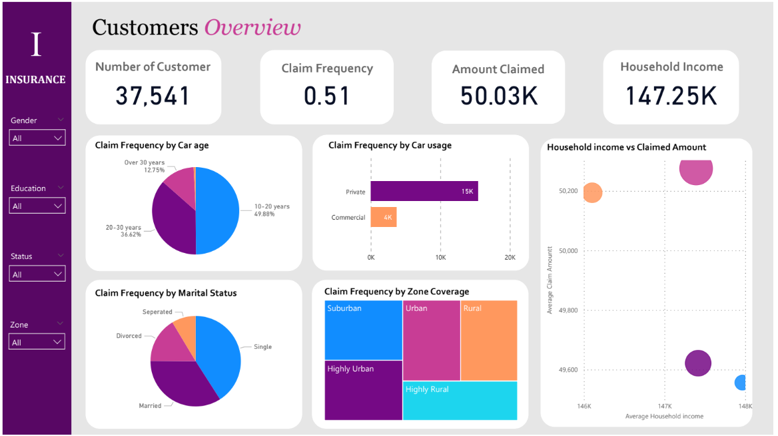

**Challenges:**

No significant challenges were encountered during the analysis, indicating the reliability of the dataset.

**Call-to-Action:**

For a more detailed exploration of the insurance policies clients' dynamics, refer to the comprehensive Insurance Clients Analysis Dashboard. [Link](https://drive.google.com/drive/folders/1YjX8G7xruP5j5K5x-rRduKlfPAibHXNO?usp=drive_link)

**Contact Information:**

For inquiries or collaboration opportunities, please contact:

- Coumba COULIBALY

- Email: coumbacoulibaly09@gmail.com

- LinkedIn: [www.linkedin.com/in/coumba-coulibaly](http://www.linkedin.com/in/coumba-coulibaly)